**HOME PAGE RESURTECH**

**Phone:** +2348168143888

**Email:** [resurtechglobal@gmail.com](mailto:resurtechglobal@gmail.com)

**Location: Don’t know what address to use yet**

**Logo**

**Catchphrase:** Reduce waste, expand access bridge the digital divide

**About Us/ Who we are**

**Who We Are**

At Resurtech, we are committed to revolutionizing electronic waste management by giving old gadgets a second life. Our platform connects individuals who no longer need their tech with those who can’t afford new devices. By doing so, we aim to reduce electronic waste and provide underserved communities with the tools they need to thrive in today’s digital world.

**Our Mission**

Our mission is simple yet impactful: to extend the lifecycle of electronic devices through donation, repair, and redistribution. We aim to reduce the environmental impact of e-waste while bridging the digital divide, ensuring that everyone, regardless of their background, has access to essential technology for personal and professional growth.

**Our Vision**

We envision a sustainable future where electronic waste is minimized and technology is universally accessible. By fostering a culture of reuse and responsible recycling, *Resurtech* strives to lead a global movement towards environmental sustainability and digital equity.

**Why We Exist**

In a world where technology evolves rapidly, many professionals upgrade their devices frequently, contributing to a growing e-waste crisis. Yet, while old gadgets become obsolete for some, they are a lifeline for others. Millions of people—especially students and aspiring tech professionals—lack access to the devices they need to learn, grow, and succeed.

At Resurtech, we believe that every old laptop or phone can still make a difference. Our platform turns "trash into treasure" by redistributing donated tech to those who need it most, extending its usefulness and empowering individuals.

What We Do

- Tackle E-Waste: We create an efficient, secure platform where used gadgets are donated, refurbished, and redistributed, helping to reduce the growing e-waste problem.

- Bridge the Digital Divide: By providing tech access to underserved communities, we give individuals the tools they need to succeed in education, employment, and beyond.

- Promote Sustainability: We encourage responsible consumption by extending the lifecycle of electronic devices and reducing environmental impact.

**Our Impact**

Through our platform, we aim to:

- Provide marginalized individuals with access to the technology they need for education and career growth.

- Reduce e-waste by extending the lifecycle of donated electronics.

- Promote a culture of sustainability and responsible recycling.

**Join Us**

At Resurtech, we believe in the power of technology to transform lives and protect the environment. Whether you’re donating a device or receiving one, you’re part of a movement that’s making tech accessible to everyone.

Give Tech Life, Give Someone Hope.

**Keep the Apply, donate, volunteer and news section**

**Apply:** **Need a laptop or know someone who does? Apply for a free one here.**

**Donate: Donate your unused devices so others can benefit from them.**

**Volunteer: Volunteer with us! Your small efforts can make a big difference for those in need.**

**Explore our news and blogs for the latest insights on related topics**

**Success story section**Let's create a world where compassion, inclusivity, and sustainability thrive. Every action counts in protecting human dignity and preserving the earth for future generations.

**Testimonial section**

"Testimonials coming soon! Be the first to share your experience and help inspire others."  
Please help create a google form link where testimonials can be shared. The only section on the form should be name, location, testimony.

**Keep the Newsletter subscription section**

**Mission in one sentence**To reduce e-waste by repairing and redistributing tech to underserved communities.  
Other items in that section is good to go aside phone number

**APPLY & DONATE SECTION- HOME PAGE**

**Apply for a free device**  
If you or someone you know needs a laptop to support school, college, or work, apply here!

**Donate**

Electronic waste is the fastest-growing waste stream globally, with an estimated **50 million tons** produced annually. Yet, discarded gadgets contain valuable metals and minerals worth approximately **$62.5 billion** each year. [Unfortunately, only about one-fifth of the world’s e-waste is recycled1](https://gridfiti.com/aesthetic-study-websites/).

On the other hand, during covid, the digital inclusion gaps for students were covered. However, it’s undeniable that there are still students who don’t have access to computer devices, and not all students are equally proficient with digital media. [Students without internet or computing devices face serious disadvantages in their education2](https://us.boell.org/en/2021/03/31/no-access-no-class-challenges-digital-inclusion-students), and socio-demographic factors, such as parental income, education, race, ethnicity, and immigration status, significantly influence their digital skills.

E-waste is a global concern, and responsible disposal is essential. When donated to students, they are empowered learn, collaborate, and thrive in an increasingly digital world. Instead of throwing away your devices, donate them here to those in need.

**CONTRIBUTION & SUCCESS STORY SECTION**

Its good to go. Just edit as the previous apply, donate, volunteer and news and testimonial earlier listed.

**BLOGS & NEWS**

Digital Inclusion in the 21st Century: What It Means and How We’re Helping

From Trash to Treasure: How Donated Tech is Empowering Underserved Communities

Why E-Waste is the Fastest-Growing Waste Stream and How We Can Fight It

The Lifecycle of Your Old Laptop: From Donation to Redistribution

The Hidden Cost of Electronic Waste on the Environment

How Resurtech is Pioneering Sustainable E-Waste Management in Africa

You can pick the best three or use all six

**APPLY FOR HELP TAB**

Apply for Assistance

What to Expect

Resurtech will be calling for donations for one month, during which individuals can start applying for devices. After the donation period, the refurbishment process will begin, and here’s what you can expect after submitting your application:

- Your application will be reviewed, and if selected, we will contact you directly via email.

- Please note that recipients will be responsible for the delivery cost. This policy ensures that recipients take ownership of the device as they will have contributed to its delivery.

- Currently, we do not donate outside of Nigeria, but we are working towards expanding our reach across all African countries. If you are applying from outside Nigeria, please submit your application anyway; it will be prioritized once we can facilitate delivery to your location.

**How to Apply**

To apply, please complete the form on this page, ensuring you provide as much detail as possible:

- Share a bit about yourself! We’d love to get to know you. (If you're applying on behalf of someone else, include their information.)

- Describe why you need a device, and its intended use—be it for school, work, or another purpose. The more details you provide, the better we can address your needs.

The form is okay as it is only to include a space for LOCATION

OUTBOUND Link to SUBMIT TO: [resurtechglobal@gmail.com](mailto:resurtechglobal@gmail.com) or what do you think?

We don’t have testimonial yet for the next section. Every other thing on that page works

I’ll love if this can be fixed somewhere if possible

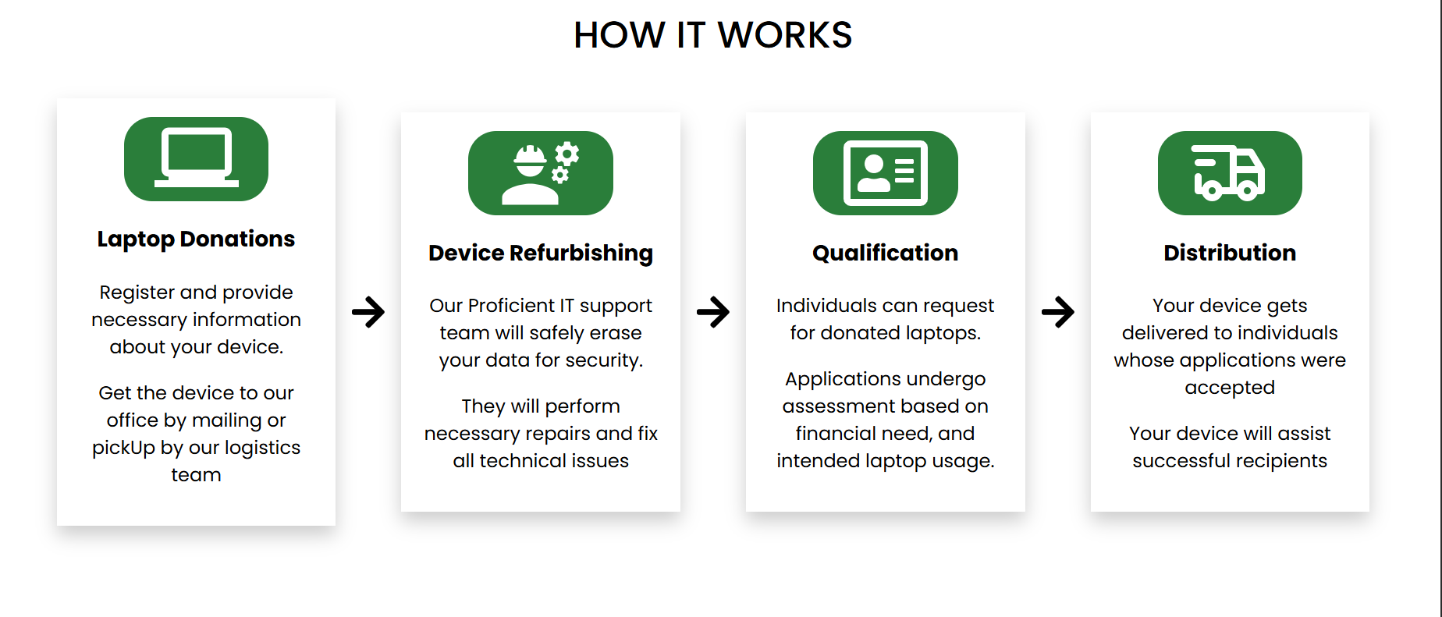

**TAKE ACTION TAB**

**DONATE**

**Donation Guidelines**

At Resurtech, we currently accept donations of old laptops. Before you donate, please review our guidelines:

- Functionality: The laptop should be in working condition and able to power on. If otherwise, please donate regardless for a responsible recycling.

- Security: If possible, please wipe all personal data, including files and passwords, to protect your privacy. If you're unable to do this, we will securely wipe the device during the refurbishment process.

- Cleanliness: Please ensure the laptop is cleaned and sanitized to prevent the spread of germs.

- Communication: Be clear about the laptop’s condition and any defects that may affect its functionality so it can be properly fixed.

- Anonymity: Donations are kept anonymous unless you choose to include a note with your name or a thoughtful message for the recipient.

**Refurbishing Process**

The refurbishing process includes:

1. Replacement of Parts: We may replace old or broken parts to ensure the laptop meets performance standards for modern applications.

2. Data Wiping: All personal data will be securely wiped to protect your privacy.

3. Recycling: We also accept totally condemned laptops for proper recycling. Your donation helps us manage electronic waste responsibly. As part of our future plans, we are working on expanding our recycling efforts to include various types of electronics, such as:

- Desktops

- Tablets

- Smart devices (e-readers, mobile phones, etc.)

- Computer monitors

- Virtual assistants (Alexa, Google Assistant, Siri, etc.)

**Accepted Devices**

Currently, we only accept laptops for donation.

**Important Note About Apple Devices:**

Before donating Apple laptops, please ensure they are removed from the owner's iCloud account to allow others to register them. If you need assistance with this process, please reach out to us!

**Donation Drop-Offs**

To make donating easier, we will coordinate with you to pick up your laptop from your location. Alternatively, if it's more convenient, you can mail it to our office.

For any questions or concerns, please call us at +23468143888. Thank you for your support in helping us reduce electronic waste and provide devices to those in need!

TAKE ACTION – VOLUNTEER CALL  
Join Us in Making a Difference!

At Resurtech, our mission to provide free tech devices is essential in bridging the digital divide and enhancing access to technology for those in need, all while minimizing electronic waste in landfills. This effort often involves collaboration with organizations dedicated to increasing digital literacy and ensuring equitable technology access. You can contribute meaningfully by volunteering in the following ways:

- Raise Awareness: Help us spread the word about Resurtech! Encourage your friends, family, and social media followers to donate or refer individuals who could benefit from our services.

- Act as a Community Lead: Take charge in your local area by becoming a Resurtech community leader. You can implement our initiatives at a grassroots level, and we’ll provide guidance based on our experiences.

- Facilitate Device Collection: If you own a business or know someone who does, consider hosting a donation drop-off location. Alternatively, you can collect devices from your network of friends, family, and colleagues.

- Assist with Device Refurbishment: If you have technical skills in repairing devices (laptops, tablets, phones, etc.), we would greatly value your assistance. Tasks may include upgrading components and installing necessary operating systems and applications.

- Offer Training and Support: Help individuals learn how to use their tech devices effectively. Provide training on hardware and software that can improve their learning, communication, and productivity.

- Contribute to Internal Functions: Join us in various internal roles that help keep Resurtech thriving. Opportunities include project management, organizing events, brainstorming sessions, website development, UI/UX design (for marketing materials), and managing our social media presence (Instagram, Twitter, Facebook).

If you’re interested in volunteering or have questions, please reach out to us. Together, we can create a lasting impact in our communities!

TAKE ACTION - SUBSCRIBE CALL

Sign Up for Our Newsletter

Be part of the change by staying connected with us! Subscribe to our newsletter for the latest updates on our events, initiatives, and opportunities to contribute to a more inclusive and sustainable digital future. Together, we can make a significant difference for our communities and the planet.

NEWS AND BLOGS

BLOG 1

**Digital Inclusion in the 21st Century: What It Means and How We’re Helping**

In the digital age, access to technology is more than just a convenience—it’s a necessity. From education to employment and even healthcare, the digital world offers countless opportunities. However, millions of people around the globe remain excluded from this technological revolution, creating what we call the “digital divide.”

BLOG 2

### ****From Trash to Treasure: How Donated Tech is Empowering Underserved Communities****

When your old phone, laptop, or tablet stops working, what do you do with it? For many people, these devices end up in the trash, contributing to a growing problem of electronic waste. But what if that “trash” could become someone else’s treasure?

BLOG 3

### ****Why E-Waste is the Fastest-Growing Waste Stream and How We Can Fight It****

Electronic waste, or e-waste, is currently the fastest-growing waste stream in the world. From smartphones and laptops to refrigerators and televisions, the average person disposes of numerous electronic devices in their lifetime. But what happens to all that waste?

BLOG 4

### ****The Lifecycle of Your Old Laptop: From Donation to Redistribution****

Ever wonder what happens to your old laptop when you donate it? At Resurtech, we believe in giving technology a second life. Let’s take a closer look at the lifecycle of a donated laptop.

BLOG 5

### ****How Resurtech is Pioneering Sustainable E-Waste Management in Africa****

Africa faces significant challenges with e-waste, but also incredible opportunities. At Resurtech, we’re working at the intersection of technology, sustainability, and social impact to create a solution that benefits both people and the planet.

BLOG 6

### ****The Hidden Cost of Electronic Waste on the Environment****

Every time we throw away a gadget, we’re contributing to a much bigger problem. The environmental cost of electronic waste is staggering, but often overlooked.

**CONTACT PAGE**

Have Questions?

Feel free to reach out! Whether you have inquiries, need more information, want to provide feedback, or share your thoughts, we’re here to listen. We’re always eager to discuss anything related to our mission!  
Form is good. Email, Location, contacts are above  
Date: Mondays – Fridays 9am -5pm